Problem 1:

|  |  |  |
| --- | --- | --- |
| TABLE | PRIMARY KEY | FOREIGN KEY(S) |
| EMPLOYEE | EMP_CODE | EMP_NAME; JOB_CODE |
| BENEFIT | EMP_CODE | PLAN_CODE |
| JOB | JOB_CODE | JOB_DESCRIPTION |
| PLAN | PLAN_CODE | PLAN_ DESCRIPTION |

Problem 2:

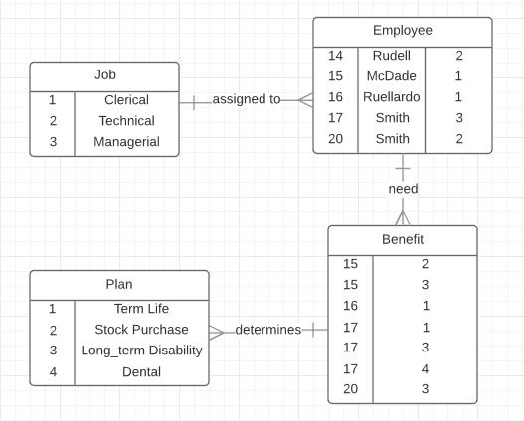

Problem 3:

|  |  |  |
| --- | --- | --- |
| TABLE | ENTITY INTEGRITY | EXPLANATION |
| EMPLOYEE | N | Every employee has a single job/JOB_CODE and EMP_CODE, however having the same name occur with different information makes it difficult to discern a single employee. |
| BENEFIT | Y | Already noted by the (supposed) relationship, the employees have multiple plans and the table clearly reflects it. |
| JOB | Y | Every JOB_CODE only associated with one JOB_DESRIPTION. |
| PLAN | Y | Every PLAN_CODE has a single PLAN_DESCRIPTION associated with it. |

Problem 4:

|  |  |  |
| --- | --- | --- |
| TABLE | REFENTIAL INTEGRITY | EXPLANATION |
| EMPLOYEE | Y | Every employee has a single job/JOB_CODE and EMP_CODE. |
| BENEFIT | N | Because of the (supposed) relationship, it is impossible to reference a single plan for an employee without another table for that employee. |
| JOB | Y | Every JOB_CODE only associated with one JOB_DESRIPTION. |
| PLAN | Y | Every PLAN_CODE has a single PLAN_DESCRIPTION associated with it. |

Problem 5: ( “;” = AND, “/” = OR)

|  |  |  |  |  |  |
| --- | --- | --- | --- | --- | --- |
| Table | Primary Key | Superkey | Canidate Key | Foreign Key | Secondary Key |
| CHARTER | CHAR_TRIP | CHAR_TRIP | CHAR_TRIP | AC_NUMBER; CUS_CODE | N/A |
| AIRCRAFT | AC_NUMBER | AC_NUMBER; MOD_CODE | MOD_CODE | MOD_CODE | MOD_CODE |
| MODEL | MOD_CODE | MOD_CODE; MOD_NAME | MOD_NAME / MOD_CODE | N/A | MOD_NAME |
| PILOT | EMP_NUM | EMP_NUM | EMP_NUM | N/A | N/A |
| EMPLOYEE | EMP_NUM | EMP_NUM; EMP_TITLE; EMP_FNAME; EMP_LNAME; EMP_INITIAL | EMP_NUM / EMP_TITLE; EMP_FNAME; EMP_LNAME; EMP_INITIAL | N/A | EMP_TITLE; EMP_FNAME; EMP_LNAME; EMP_INITIAL |
| CUSTOMER | CUS_CODE | CUS_CODE; CUS_LNAME; CUS_FNAME; CUS_INITIAL; CUS_PHONE | CUS_CODE/ CUS_LNAME; CUS_FNAME; CUS_INITIAL; CUS_PHONE | N/A | CUS_LNAME; CUS_FNAME; CUS_INITIAL; CUS_PHONE |

Problem 6: 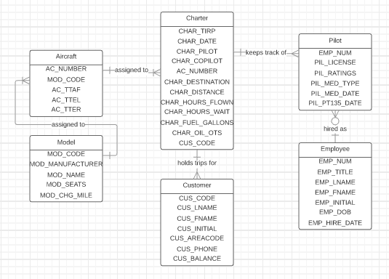

Problem 7:

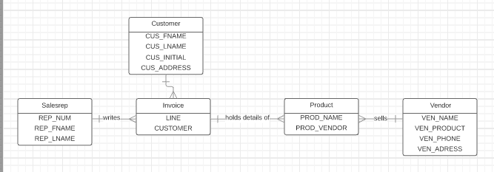

Problem 8:

